**Top IoT Sensors**

1. Accelerometers
2. Air quality sensors
3. Biomedical sensors
4. Chemical sensors
5. Electric current sensors

**1. Accelerometers**

Accelerometers measure acceleration — the change in speed, direction and intensity of movement.

**How is the data from these IoT sensors used?** Accelerometers are used to collect data from connected devices such as wearables, medical alert devices, cameras and cars to track activity. Tablets and smartphones also rely on accelerometers to know when to rotate displays based on the device’s physical orientation.

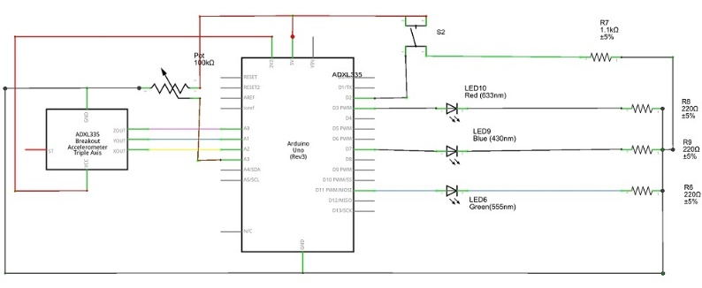**Working Principles:**

1. **Sensing Mechanism**: Accelerometers typically use small micro-electromechanical systems (MEMS) to detect acceleration. Inside, there’s a small mass suspended by springs within a frame.
2. **Movement Detection**: When the device moves, the mass inside shifts due to acceleration. This movement changes the capacitance between the mass and the frame, which is detected and measured.
3. **Signal Conversion**: The changes in capacitance are converted into an electrical signal. This signal is processed and translated into acceleration data.

2. Air quality sensors

Air quality sensors are **electronic devices that detect and quantify the concentration of pollutants and contaminants present in the air**. These sensors play a critical role in safeguarding human health and environmental well-being in both industrial and residential settings.

Working principle:

Air quality sensing devices monitor noxious gases and particulate matter. More specifically, they focus on tracking the number, and size, of gaseous or particulate elements in the air. The most common pollutants and gases that air quality sensors measure are particulate matter, ozone, sulfur dioxide, nitrous oxide, and carbon monoxide.

What do air quality sensors measure:

* 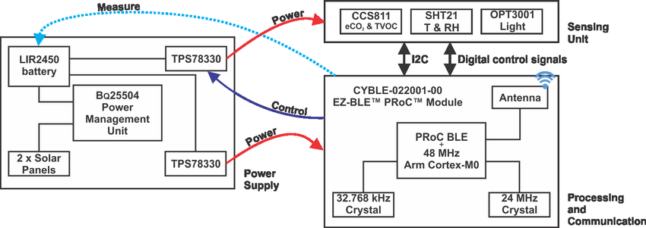Ozone
* Particulate matter
* Nitrous oxide
* Carbon monoxide
* Sulfur dioxide

3.Biomedical sensors:

Biomedical sensors are **used to gain the information on body and pathology**, which is a branch of biomedical engineering. Biomedical sensors are classified into physical sensor, chemical sensor and biosensor

Working principle:

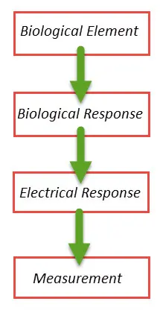 They are **small, powerful devices capable of analyzing biological samples to understand their function, composition and structure**. This is achieved by converting a biological signal or resp easurable response.

1. A device used to measure biologically-derived signals b)
2. A device that “senses” using “biomimetic” (imitative of life

strategies ex.,“artificial nose”

1. A device that detects th e presence of biomolecules
2. 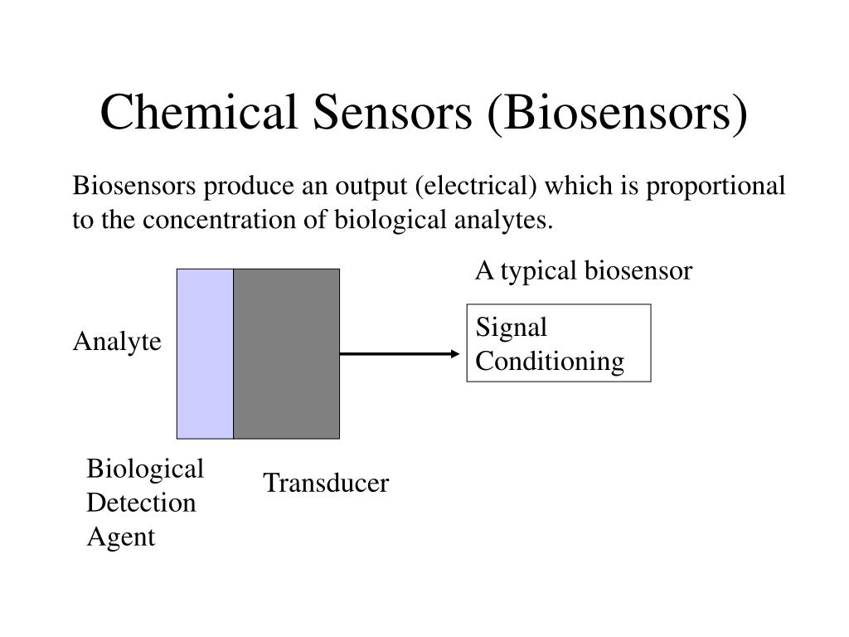
3. Chemical sensor:

A sensor that is used to **measure & detect chemical quantities within an analyte** (composition, existence of a particular element (or) ion, chemical activity, concentration) to convert it into electronic data is known as a chemical sensor.

Working principle:

Chemical Sensors work by converting the chemical interactions between the analyte and the sensor into a measurable signal, such as a change in color or a voltage output. The basic working principle of chemical sensors involves two main steps: **detection and amplification**.

1. **Recognition Element**: This is the core part of the sensor that interacts directly with the chemical substance to be detected. It could be an electrode, a semiconductor, or any material that can undergo a chemical reaction with the target analyte (the substance being measured).
2. **Transducer**: The transducer converts the chemical reaction that occurs at the recognition element into a measurable signal. This signal can be electrical, optical, or even thermal. For example, in electrochemical sensors, the chemical reaction produces a change in electrical potential or current, which the transducer detects.
3. **Signal Processor**: The raw signal from the transducer is often weak or noisy, so it needs to be processed to extract meaningful information. The signal processor amplifies, filters, and converts the signal into a form that can be easily interpreted.
4. **Output**: Finally, the processed signal is presented as an output. This could be displayed on a screen, sent to a computer for further analysis, or used to trigger an alarm or other response.
5. 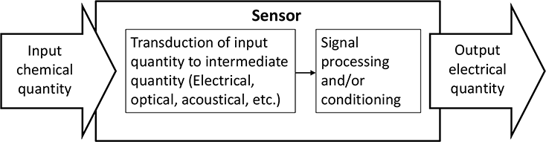

5.Electric current sensors:

A current sensor **detects and measures the electric current passing through a conductor**. It turns the current into a quantifiable output, such as a voltage, current, or digital signal, which may be utilised in a variety of applications for monitoring, control, or protection.

Working principle:

Electric current sensors are fascinating devices that measure the flow of electrical current in a circuit. They operate based on several principles, depending on the type of sensor. Here are a few common working principles:

**Types of Electric Current Sensors and Their Principles:**

1. **Hall Effect Sensors**: These sensors use the Hall effect, which occurs when a magnetic field is applied perpendicular to the current flow in a conductor. This interaction generates a voltage, known as the Hall voltage, which is proportional to the current. This voltage is measured and converted into a readable current value.
2. **Current Transformers (CTs)**: These sensors work like traditional transformers, where the primary winding carries the current to be measured. The secondary winding generates a current proportional to the primary current, which can then be measured with standard equipment.
3. **Rogowski Coils**: These are air-cored coils wrapped around a conductor. They measure the rate of change of current by inducing a voltage in the coil proportional to the rate of current change in the conductor. This signal is then integrated to provide a measurement of the current.
4. **Shunt Resistors**: These are precision resistors placed in series with the load. The voltage drop across the resistor is proportional to the current flowing through it, according to Ohm's Law (V = IR). This voltage drop can be measured and converted to a current reading.

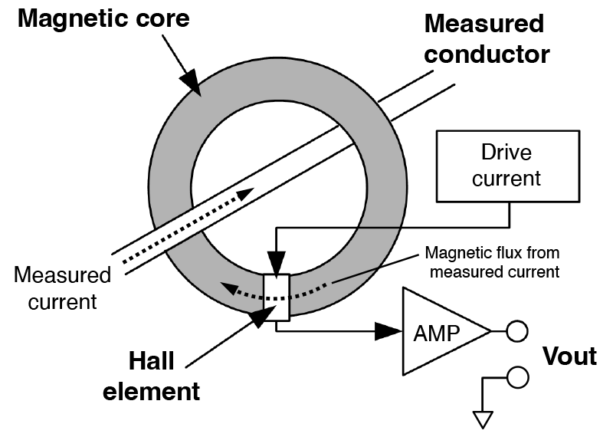

By

M.Mahizhan